Report OOO "Remmontazh" in the field of sustainable development

2016 year
Content

1 | Message from the Director……………………………………………... | 3
2 | About us………………………………………………………………... | 4
2.1 | The company "Remmontazh"………………………………………….. | 4
2.2 | Production efficiency…………………………………………………... | 7
3 | Description of practical actions………………………………………… | 9
3.1 | Human rights…………………………………………………………… | 9
3.2 | Labour relations………………………………………………………… | 12
3.3 | Environment protection………………………………………………… | 15
3.3.1 | Environmental policy…………………………………………………... | 15
3.3.2 | Industrial environmental control ……………………………………... | 36
3.4 | Anti-corruption………………………………………………………... | 44
4 | Conclusion.…..………………………………………………………..... | 47

1 Message from the Director

The company Remmontazh presents to you the traditional annual report in the field of sustainable development. In it, our company sums up the results of 2016, in which we told about our achievements over the past year.
Providing services for collection, transportation and disposal of waste of IV - V hazard class, we are engaged in socially significant business. The welfare of people, the city, and the district depends on the results of our activities. We work to improve the economic, social and environmental well-being of the city and the district.
ООО «Remmontazh» constantly focuses on increasing the efficiency of production, as the basis for further development of the company. Uses modern information technologies in its activities in logistics, in accounting for education and waste movement, in monitoring the quality of services provided in the field of communication with waste. This has a very positive effect on the growth of labor productivity.
In 2015, «Remmontazh» joined the world's largest global initiative on sustainable development, known as the UN Global Compact. Thus, we committed ourselves to conduct all activities in accordance with ten basic principles from the field of human rights, labor relations, environmental protection and combating corruption.
We hope that our report on sustainable development will be a useful tool for interaction with stakeholders.

Yours faithfully,
Zakiryanov Radik Ahnafovich
Director of OOO «Remmontazh»

2 About company

2.1 The company "Remmontazh"

OOO «Remmontazh» (Kirov, Kaluga region), a member of the Kaluga Chamber of Commerce and Industry - a company that provides services in the field of handling waste of the IV class of danger in the Kirov, Baryatinsky and Lyudinovsky districts of the Kaluga region.
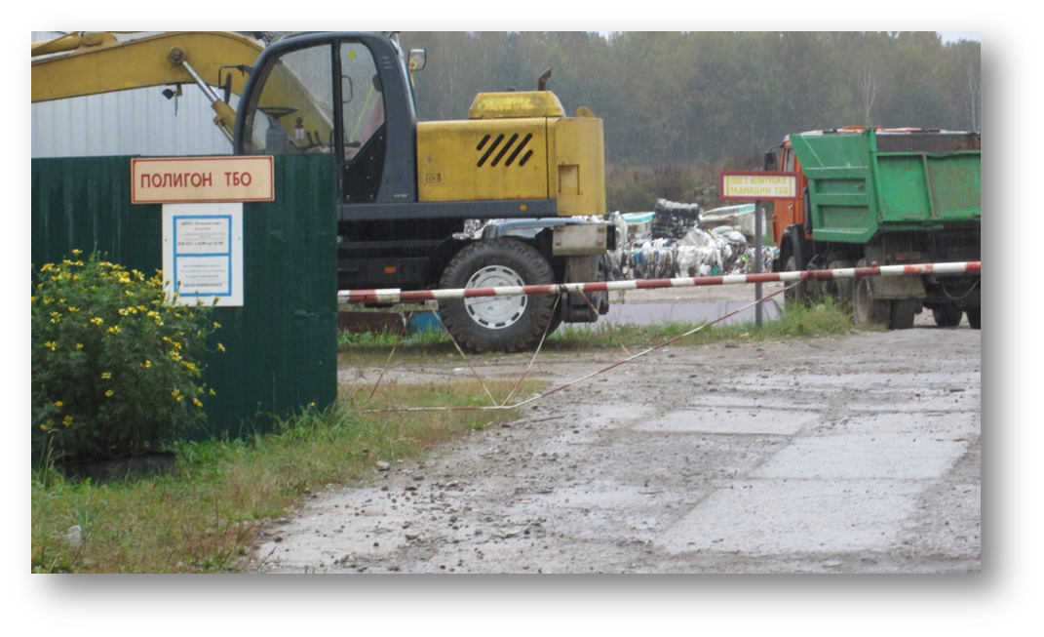

The successful production activity of the small enterprise and the introduction of innovations in the improvement of the services that are relevant for the region and all of Russia, combined with active educational activities aimed at the formation of ecological culture among the local people, deserve the high appreciation of the society.

Within the framework of the implementation of the "Zero Waste" Program, Remmontazh specialists developed a technical design for an automated waste sorting station with a capacity of 18,000 tons per year (for 1 shift operation). The design organization has developed design and estimate documentation for its construction. There is a permit for the construction of an automated waste sorting station. Currently, the general contractor for the construction is being selected. It is planned to conduct voluntary certification of the project and construction of the facility for compliance with the "Green Standards". Investments in the implementation of this project amount to 62.5 million rubles
Automated waste sorting will fully comply with the requirements of federal legislation prohibiting the disposal and placement of certain types of waste at the TKO firing range, which come into force on 01.01.2019.
The goal is to reduce the anthropogenic pressure on the environment and improve the environmental situation in the south of the Kaluga region.
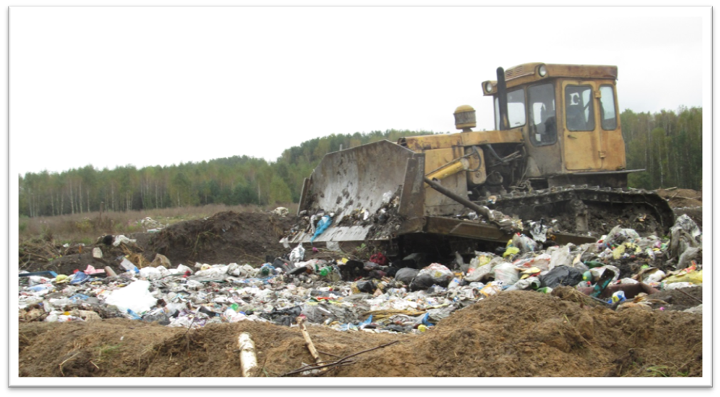

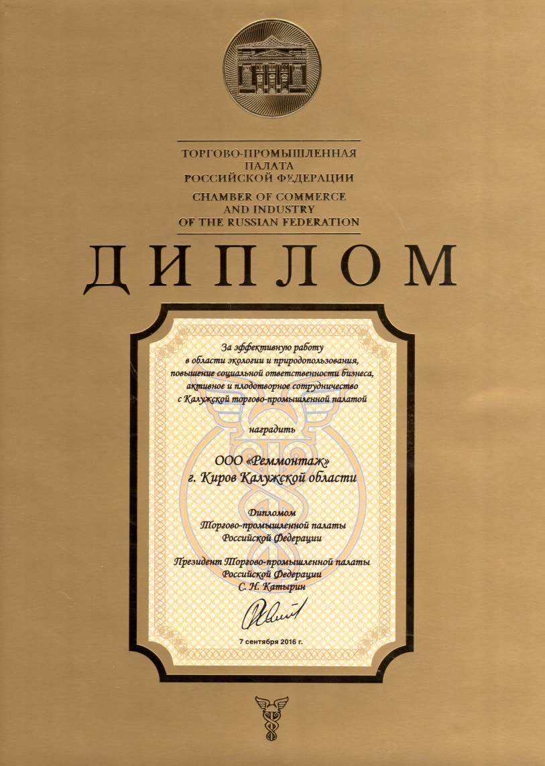
In 2016, «Remmontazh» won the competition of the Russian Chamber of Commerce and Industry in the field of entrepreneurial activity "Golden Mercury" at the regional stage in the nomination "The best small enterprise in the service sector", was awarded the Diploma of the TTP of the Russian Federation "For effective work in the field of ecology and nature management, Responsibility of business. Active and fruitful cooperation with the Kaluga TTP ", Diploma of the Ministry of Natural Resources and Ecology of the Kaluga Region in the contest "ECO ORGANIZATION 2016" in the nomination "Organizations of medium and small business" for environmental education of the population.
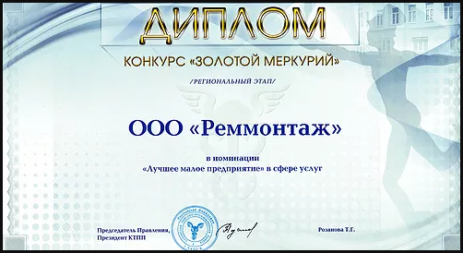
2.2 Production efficiency

Production efficiency is one of the key categories of a market economy that is directly related to the achievement of the ultimate goal of the development of social production in general and of each enterprise separately. In the most general form, the economic efficiency of production is a quantitative ratio of two quantities - the results of economic activity and production costs. The essence of the problem of increasing the economic efficiency of production consists in increasing economic results per unit of costs in the process of using available resources.
Increasing the efficiency of production can be achieved both by saving current costs (consumed resources) and by making better use of operating capital and new investments in capital (used resources).
The purpose of the analysis of the company's production efficiency is to determine the further ways of its development.
The efficiency of production must be studied and analyzed at different levels of the economy and at different stages of production, where it has its own separate indicators.
The evaluation of economic efficiency is always correlated with the goals of production in the future, but it characterizes the results of activity in the past, and its value is manifested in the present tense.
Consequently, the totality of the results of production activity for a particular period of time and is the efficiency of production.
One of the important factors of intensification and increase of production efficiency is the economy regime. Resource-saving should become a decisive source of meeting the growing needs for fuel, energy, raw materials and materials.
As a result, there is an objective opportunity and the need to improve production efficiency while realizing the rational use of natural resources, increasing the effectiveness of each unit of raw materials, resources and energy used.
With the production efficiency, the firm works as well as possible, because it benefits (marginal costs are equal to the price, with a price equal to the average total cost of profit, there are no losses). Resources are used as efficiently as possible.
Based on the results of the analysis of the main performance indicators of the firm, the following conclusions can be drawn.
Revenues from the sale of works and services increased by 8%.

3 Description of practical actions

3.1 Human rights

The company's goal is to provide comprehensive and fair quality education and to encourage lifelong learning opportunities for all.
Workers have the right to vocational training, retraining and advanced training, including training in new professions and specialties.
Observance of workers' rights is an integral part of the social policy of Remmontazh.
Observance and respect for human rights has become in our days the indicator, which largely determines the level of development of society.
For a long time it was believed that issues related to human rights only belonged to the sphere of state responsibility, and human rights were understood as compliance with basic constitutional rights.
However, today it is increasingly obvious that not only states but also enterprises can have an impact on human rights.
In official behavior, the employee must proceed from the constitutional provisions that a person, his rights and freedoms are the highest value, and every citizen has the right to inviolability of private life, personal and family secrets, protection of honor, dignity, his good name.

Work and rest time
Employment contract
The minimum wage
Payment for work during holidays
Salary
Terms of payment of wages
holidays
Common day off
Breaks for rest and nutrition
Part-time
Duration
Term of employment contract
Conclusion
Parties and content
Labor law
The pre-emptive right to leave at work with a reduction in the number or staff is family-based - with two or more dependents; Persons in the family who do not have other employees with independent earnings; Workers who received a personal injury or occupational disease in the organization; Invalids of the Great Patriotic War and invalids of military operations for the defense of the Fatherland; Employees who improve their qualifications in the direction of the Employer without interrupting their work.
The employee has the right to receive annual leave, both in full and in parts, having agreed upon this with the Employer.
The following employees have the priority right for annual leave in summer or at any time convenient for them:
A) single parents;
B) women with three or more children;
C) employees who received a labor injury;
D) any employees if they have vouchers for treatment.
Human rights are of great importance in the modern world, each person has the opportunity to implement and protect his rights.

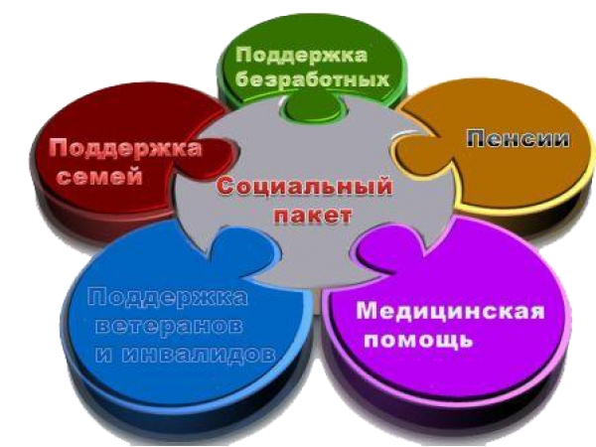
3.2 Labor relations

Labor relations are the relationship of two subjects of law: the employer and the employee. The connecting element in these relations is the labor contract, which coordinates the conditions for participation of the employee and employer in working life.
Consequently, the company's goals are to ensure gender equality; promoting sustained, inclusive and sustainable economic growth, full and productive employment and decent work for all.
The policy of Remmontazh LLC is based on the prevention of any forms of discrimination, both in the employment process and in the framework of professional activities. The Company does not discriminate on the basis of sex or age.
Employees are called upon to contribute to their official behavior by establishing in the team of business relationships and constructive cooperation with each other.
The ООО "Remmontazh" approved the Regulations on the conflict of interests of employees.
The conflict of interest clause is an internal document of Remmontazh LLC, which establishes the procedure for identifying and resolving conflicts of interest arising in the course of employees' performance of their duties.
The company Remmontazh developed a code of ethics and professional conduct of employees in accordance with the provisions of the Constitution of the Russian Federation, the Labor Code of the Russian Federation, the Federal Law "On Counteracting Corruption", other regulatory legal acts of the Russian Federation, and is based on the generally recognized moral principles and norms of the Russian Society and state.
The Code is a set of general principles of professional professional ethics and basic rules of service conduct, which should guide employees regardless of their replaced position.
In official behavior, an employee refrains from:
- any type of statements and actions of a discriminatory nature on grounds of sex, age, race, nationality, language, citizenship, social, property or marital status, political or religious preferences;
- rudeness, displays of disdainful tone, arrogance, prejudiced remarks, presentation of wrongful, undeserved accusations;
- threats, offensive language or remarks, actions that interfere with normal communication or provoke illegal behavior
An employee who has organizational and administrative authority over other employees should strive to be an example of professionalism, an impeccable reputation for them, and facilitate the formation of a morally-psychological climate favorable for effective work in the organization or its subdivision. Workers should be polite, friendly, correct, attentive and show tolerance in dealing with citizens and colleagues.

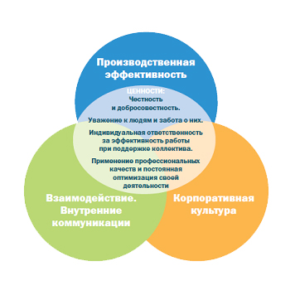
3.3 Environmental protection

3.3.1 Environmental policy

In the sustainability report for 2015, we said that Remmontazh developed and started implementing the Zero Waste Program. Within the framework of which, for the first time in the Kaluga region, Remmontazh Ltd introduced separate collection of waste in preschool educational institutions, schools, state and municipal authorities and, at the same time, provides environmental education for schoolchildren and the population of the Kirov and Baryatin districts of the Kaluga region. In 2016, Lyudinovsky district of the Kaluga region joined separate waste collection
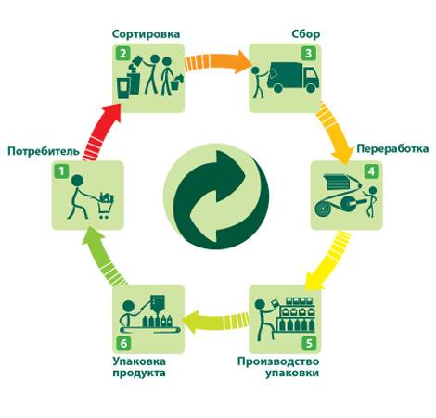
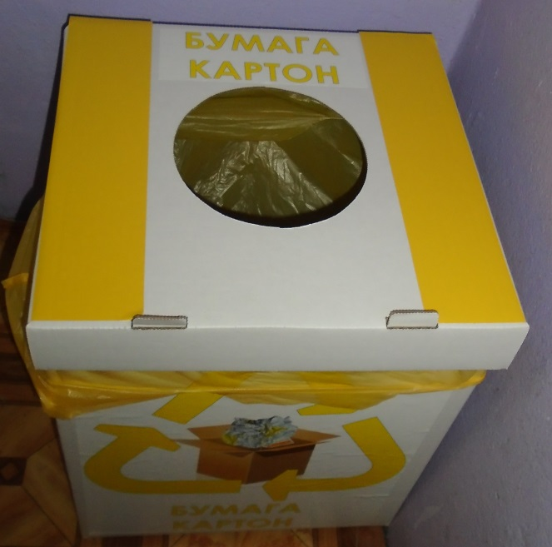
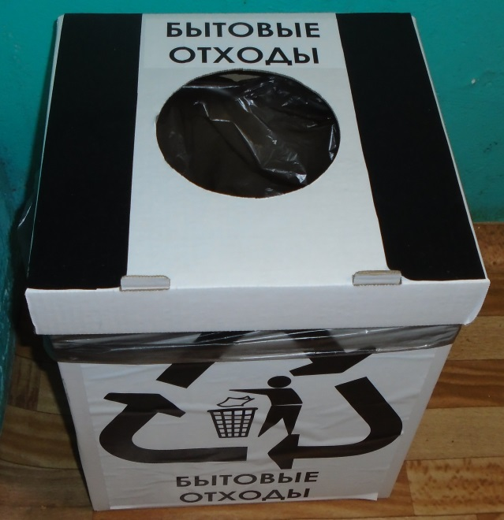

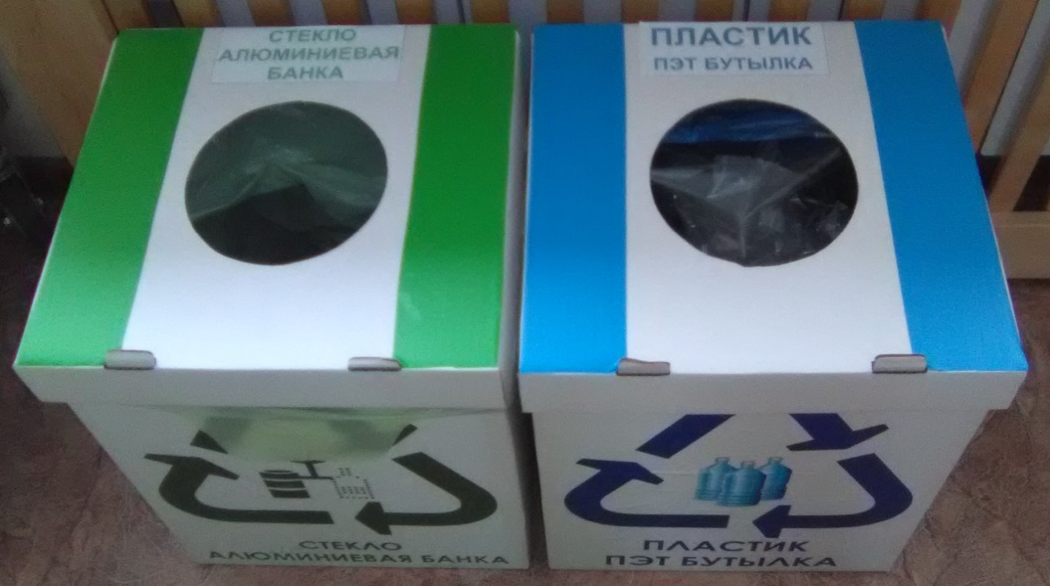
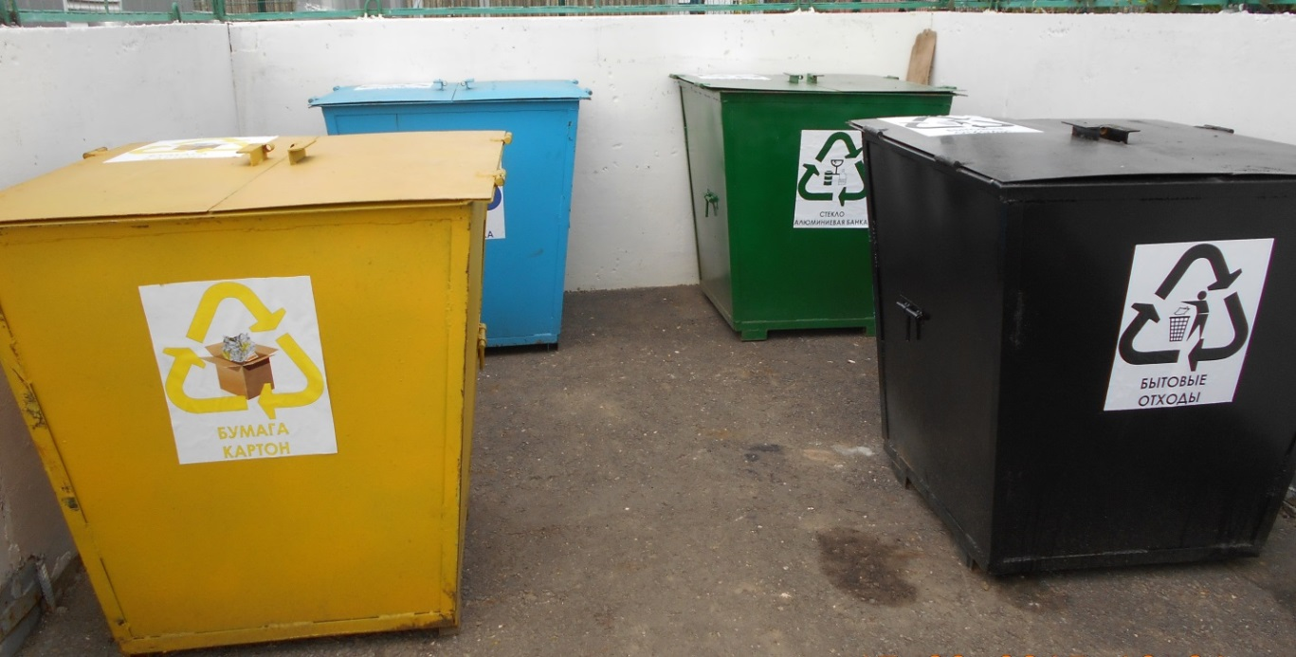
Immediately lectured in an environmental direction at several schools in the city of Kirov. In order to educate the responsible attitude to the environment of the younger generation, the students of the leading Kaluga universities took the floor. They told the students about the separate collection of solid municipal waste.
Students from higher educational institutions of the city of Kaluga were invited to Kirov director of OOO Remmontazh. He heads the organization dealing with the management of TCR in the Kirov, Baryatinsky and Lyudinovsky districts.
The creation of an infrastructure alone for the separation of TCO without clarification to the public, and why, in fact, all this is needed, can not yield positive results. Because the working group in the city on environmental education and environmental responsibility of society, which includes Remmontazh, conceived as part of the implementation of their plans in the Kirov schools a series of educational lectures.
Expanding the program of its activities, Remmontazh company invited active young people from the student environment to share their vision of solving the problem of environmental pollution. It's one thing when adults talk about this with schoolchildren, and quite another, when almost the same peers discuss this topic with them. The event involves students from various universities. The volunteer team was assembled by the Academic Council of the Kaluga Pedagogical University named after K.E. Tsiolkovsky. These guys are quite prepared. They conduct actions among the residents of the regional center.
At the lecture, the students tried to communicate clearly to the high school students sitting at the desks, what is the benefit of separating TKO.
The lecture was accompanied by a practical part. Lecturers suggested that students try to sort the waste right in the classroom. They quickly coped with the task.

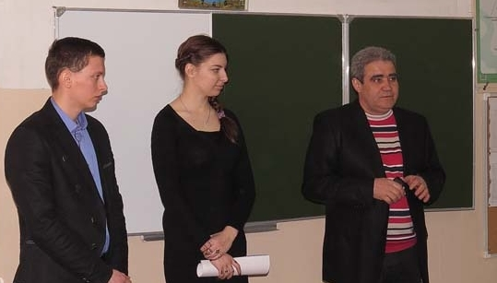
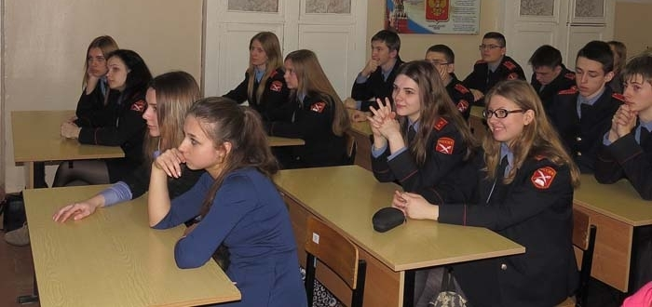
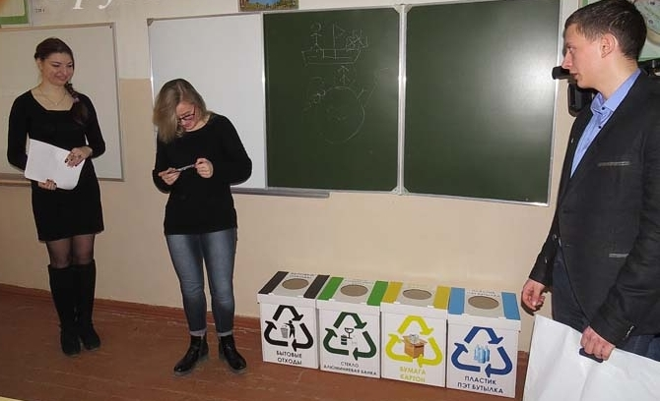
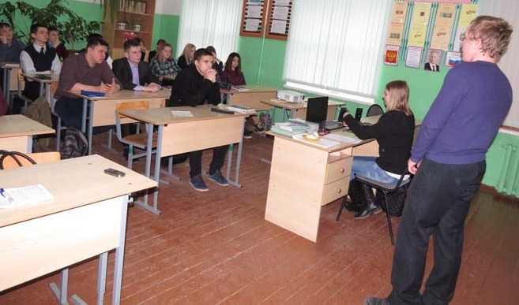
In the region, a new environmental education project was developed under the title "Eco-heroes of the Kaluga region". It is conceived by the City Administration of the city of Kaluga. The project was supported by the regional ministry of natural resources and ecology. Young environmental activists are involved in its implementation.
The main characters in the project, aimed at environmental education of the population, are Zubryash - the inhabitant of the unique reserve "Kaluga Zaseki", Kaplik - a drop of pure water - and a very useful and at the same time a dangerous drop of mercury Mercury. This friendly company introduced the inhabitants of our region to the rules of behavior in nature and the contribution they can make to the preservation of a favorable environment.
At the invitation and with the support of our firm Remmontazh, Zubryash, Kaplik and Mercury visited the Kirov district. Ecogeiro visited several educational institutions. They performed at schools № 8, № 7, № 1 and at the Sunday School of the Alexander Nevsky Cathedral, where they showed the younger pupils a theatrical performance and held an interesting quiz for them on an ecological theme.
His goal is to tell the younger generation about the amazing nature of the Kaluga region in an accessible way. From a small presentation, the children learned that in the Kaluga region there are nature conservation areas in which wonderful rare animals live.
Ecogees explained to schoolchildren that one of the effective ways to solve the issue of solid municipal waste disposal can be their separate collection. It allows for the adjustment and recycling of TCO.
Conducting a presentation and competitions, eco-gurus of the Kaluga region announced the start of an unusual contest. Children were offered to organize separate collection of waste at home. The author of the best project received a p

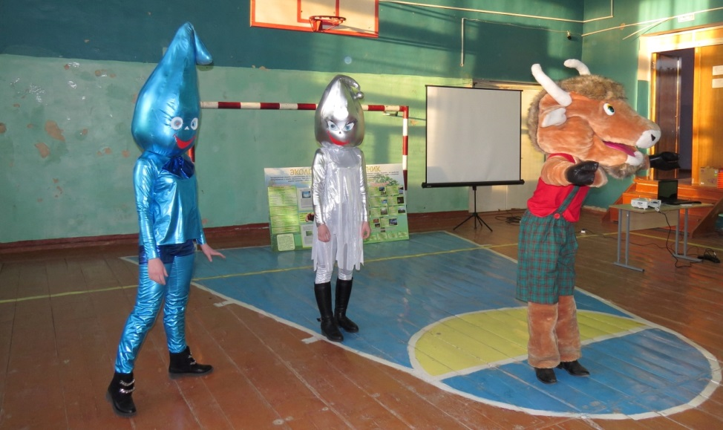
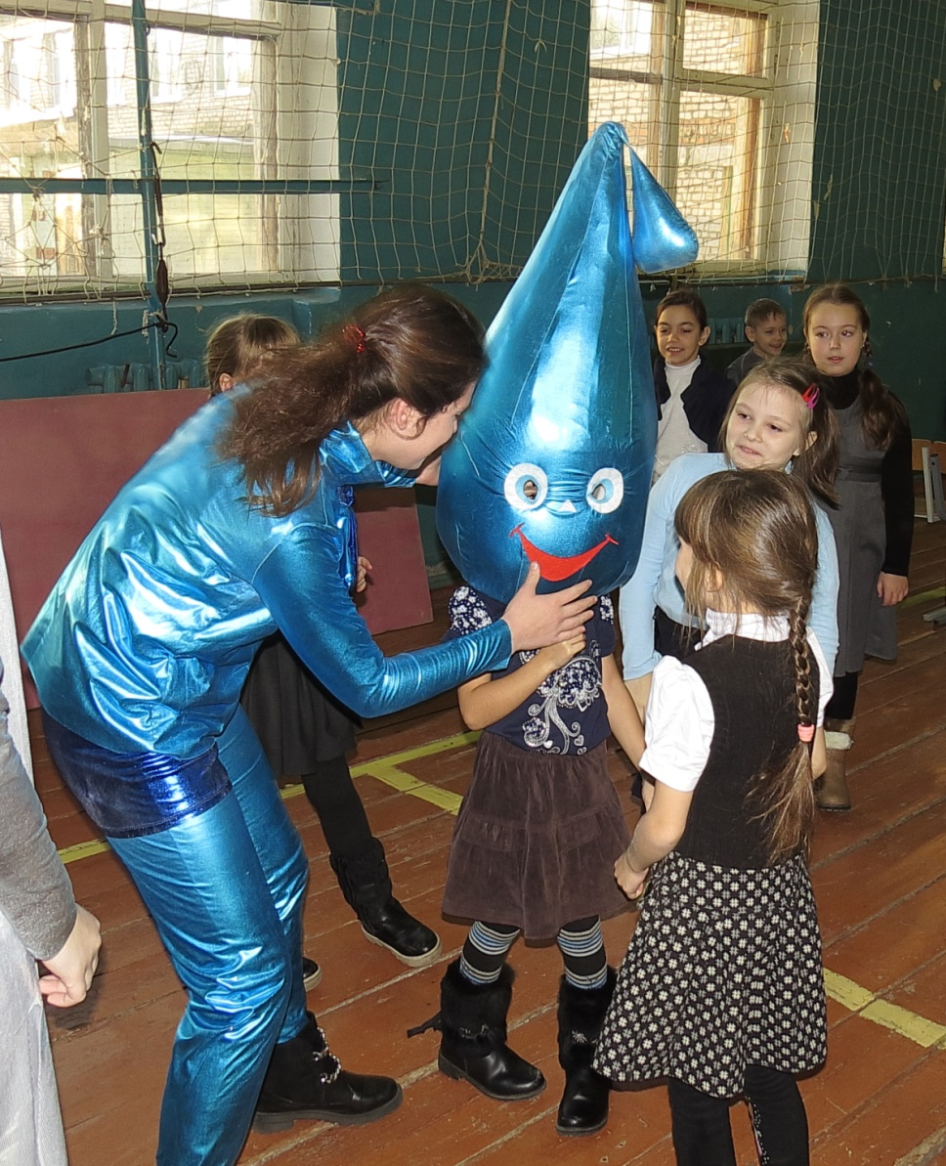

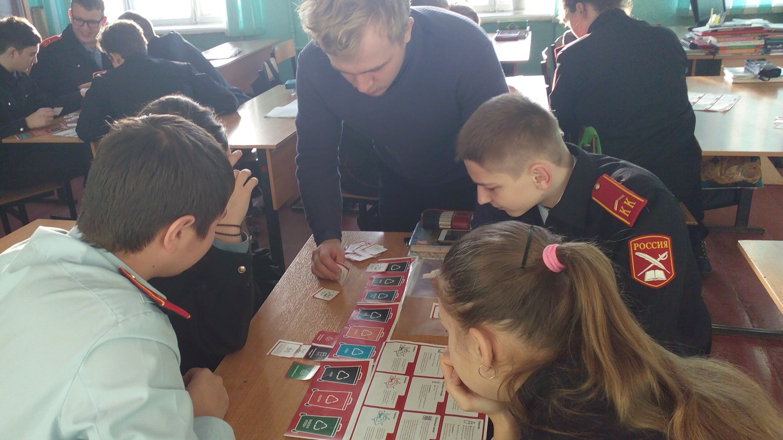
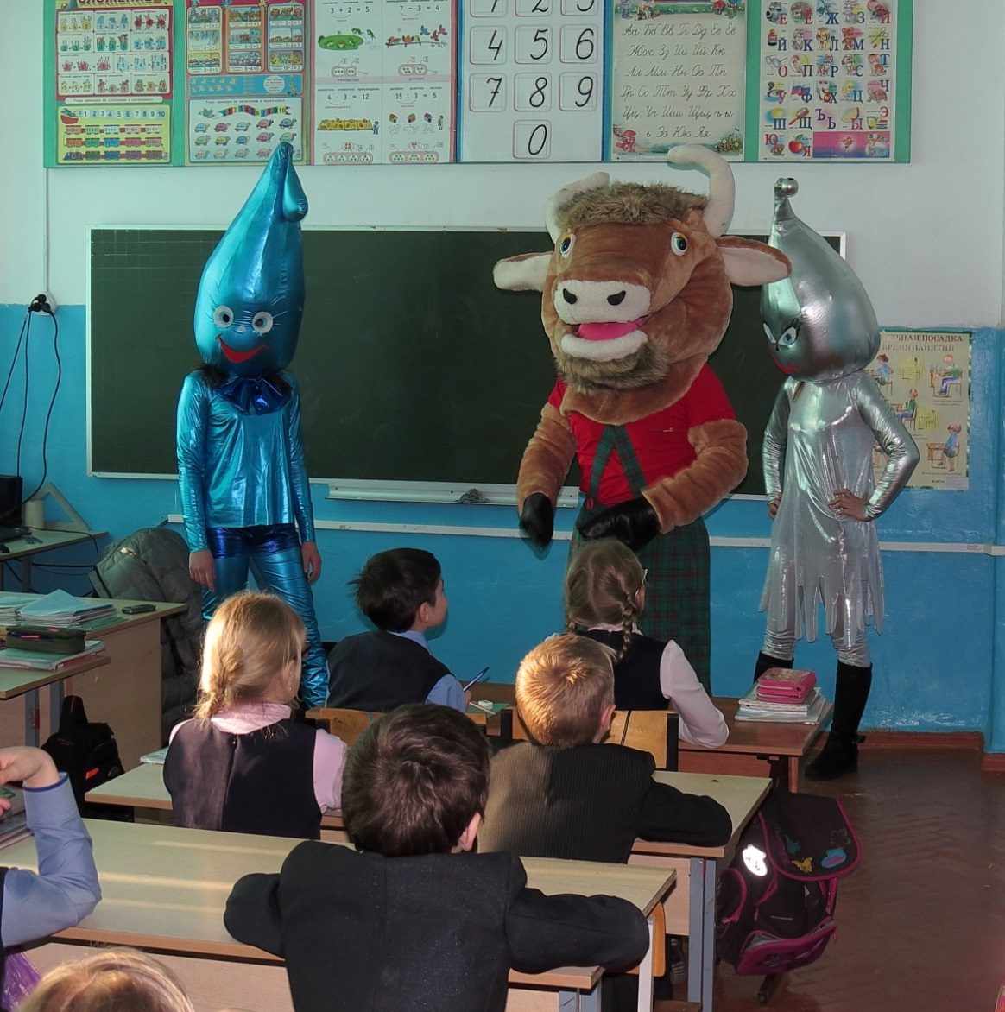
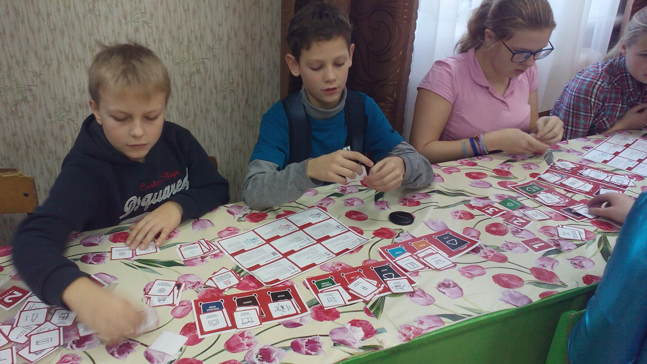
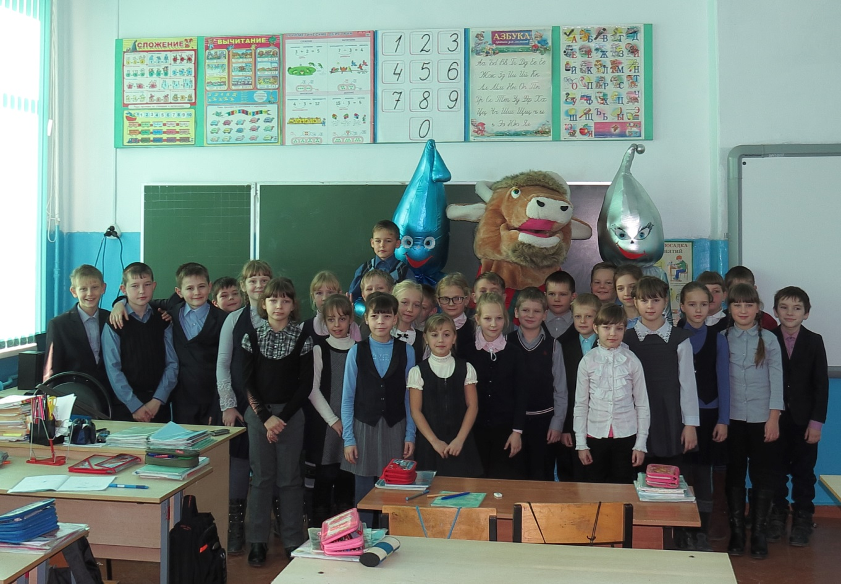
Working group of the city of Kirov on environmental education, which includes ООО «Remmontazh», held a drawing competition "The Planet for Children!" He devoted himself to three topics: "Take care of the forest", "Separate collection of waste", "Clean City".
At the invitation of the organizers responded, and participation in the competition took Bolshesavkin school, school number 1, number 2, number 7, number 8 and Sunday school of the Holy Prince Alexander Nevsky. A total of 103 works were considered by the jury.
It should be noted that the work of the jury, which included members of the working group on environmental education, was built taking into account the experts' opinion. Teachers of children's art schools of the Kirov district shared their opinion on the drawings of schoolchildren. And the jury, and teachers in most coincided in their assessments.
In the nomination "Take care of the forest" the main criterion for evaluation was artistic quality. In the category "Clean City", apart from the artistic embodiment of the idea, such criteria as: visibility and agitation (appeal) were evaluated, and in the category "Separate waste collection" - slogan and originality.
The results of the competition were summed up. The jury determined the winners, winners and holders of incentive awards.
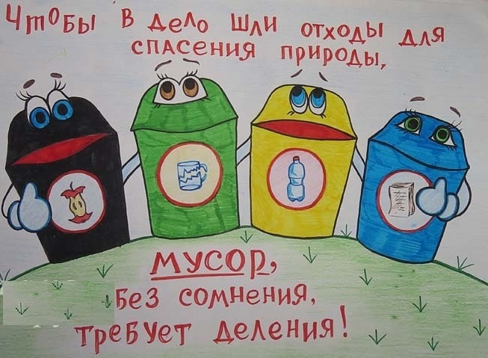
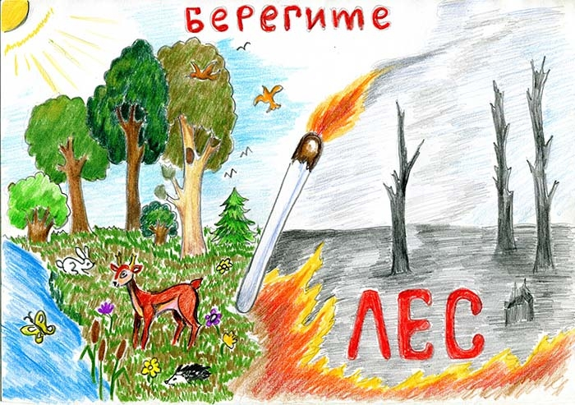
There was an action called "Victory Forests". The idea of ​​this action belongs to the working group on environmental education in the city. Landing material was purchased by Remmontazh, which is part of the Kirov eco-association. The event was attended by representatives of two general education institutions - schools number 1 and number 8. Together they planted 8,000 seedlings of pines.
Young environmentalists carried out their work in the Krasnoborsky district forestry. A felling site was chosen where former spruce plantings were planted, according to the recollections of local residents, immediately after the war. In 2013, trees on an area of ​​about 100 hectares damaged the bark beetle typographer, and they died. Landings 70 years ago in the end had to cut down.
Unfortunately, there is no natural renewal on this site, located near the village. Therefore, an artificial planting of trees was carried out, which is dedicated to the Victory Day.
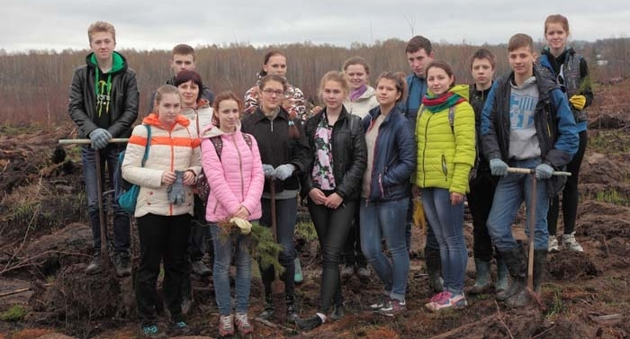
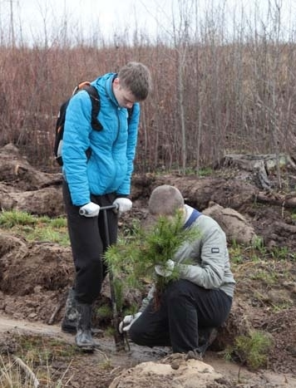
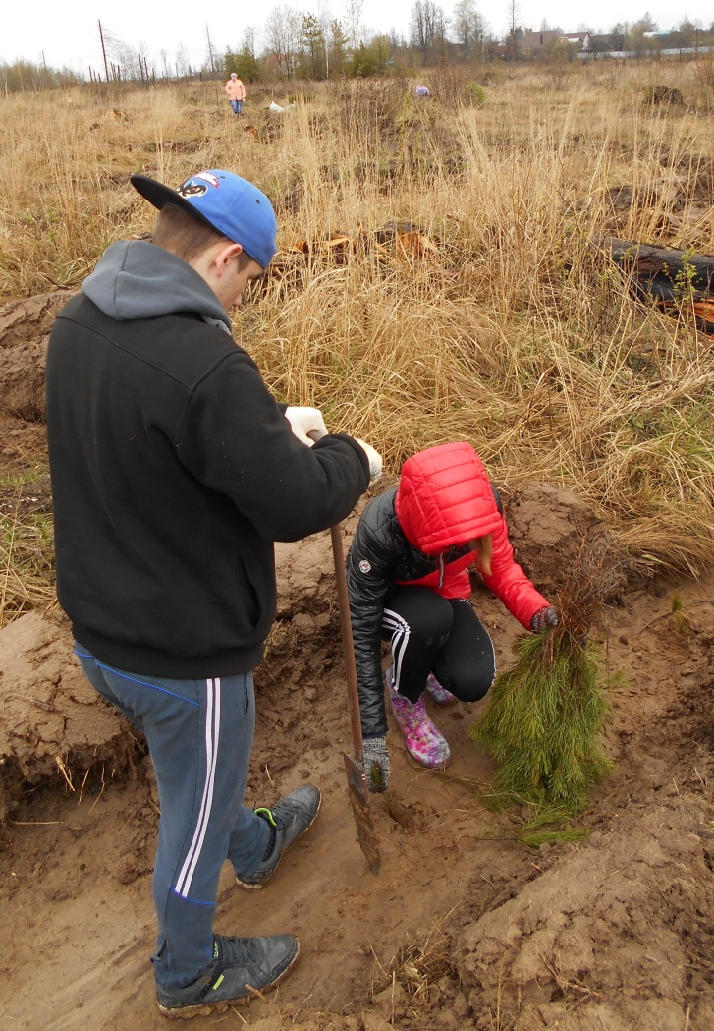
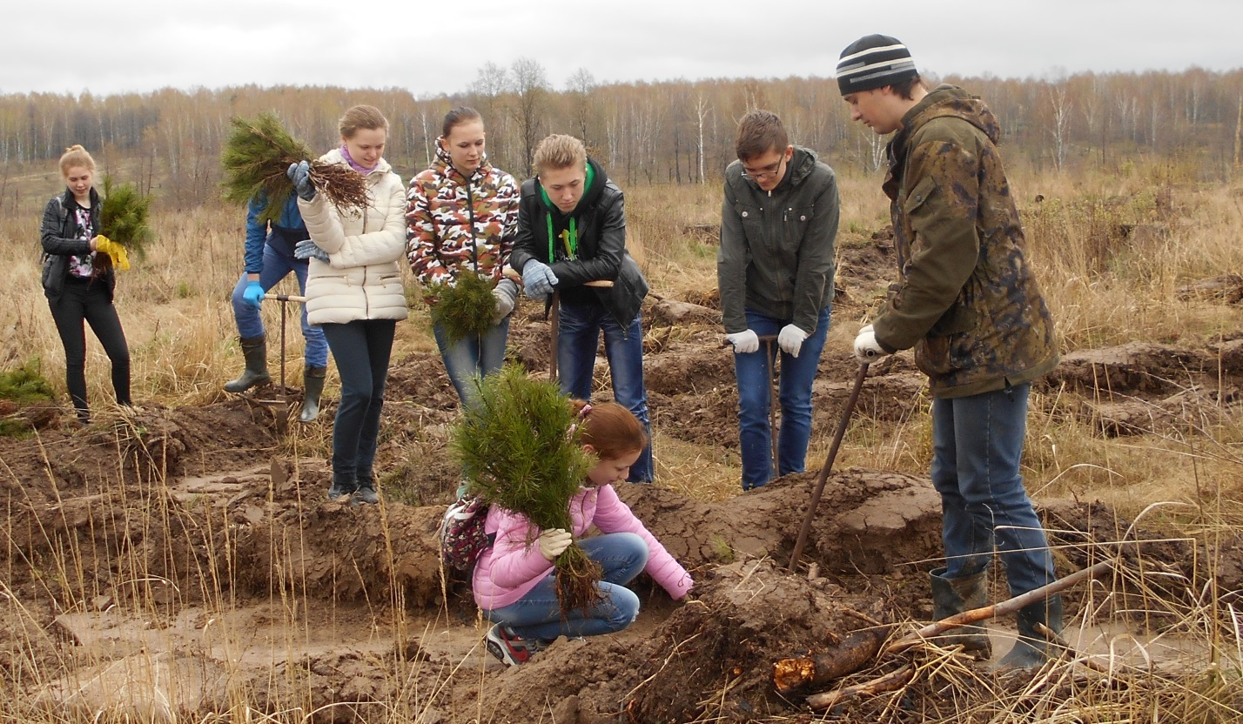
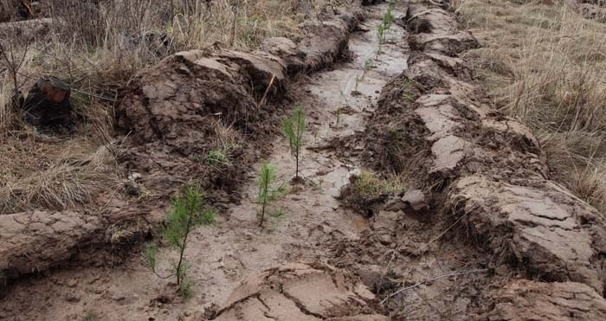
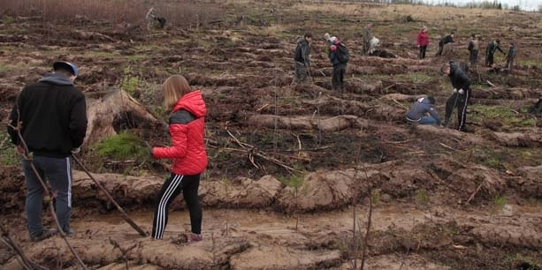
In Kirov at the Sunday School at the Alexander Nevsky Cathedral, a round table was held at the invitation of the director of ООО «Remmontazh». It discussed topics on environmental responsibility, environmental education and public education and sustainable development. Yulia Gorshkova, a member of the Public Chamber of the Kaluga Region, and a Doctor of Biological Sciences, a professor, head of the Kaluga State University named after the Kaluga State University, took part in the event. K.E. Tsiolkovsky, the head of the Committee for Nature Management and Ecology of the Kaluga Chamber of Commerce and Industry Igor Lykov.
Also, the editor-in-chief of the Kirov regional newspaper «Banner of Labor», the head and lecturers of the Kirovsky district branch of the KROZO Znanie Society, teachers of biology, geography, chemistry, ecology of the city's schools, library staff, representatives of Remmontazh , Students of Kaluga State University and others.
At the round table in her speech, Yulia Gorshkova presented the main directions of the transition to the sustainable development model of the Kaluga region, outlined the need for continuous universal environmental education and public education, and raised the issues of environmental and social responsibility of business.
Igor Lykov in his report presented information about the main environmental problems in the Kaluga region and ways to solve them, spoke about the activities of the Institute of Natural History of KSU Tsiolkovsky, on scientific research and development of students and graduate students in the field of environmental protection.
The participants of the round table discussed the problems that arise in the implementation of environmental education, upbringing and education programs, and outlined possible directions for the development and improvement of this activity in the Kirovsky district.

After the roundtable, Yulia Gorshkova and Igor Lykov, accompanied by the employees of Remmontazh, visited the secondary school №1 in Kirov where they could see how separate waste collection was organized and carried out. Then, for the participants of the "round table" an interesting excursion took place on the enterprise "Remmontazh" and information on the activities of the society on waste management was presented.

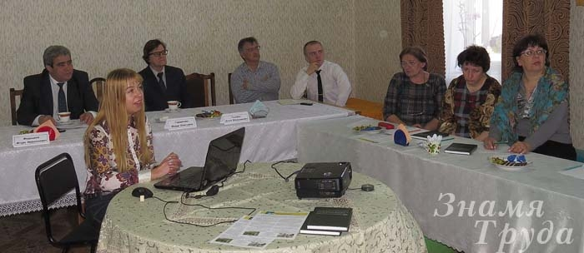
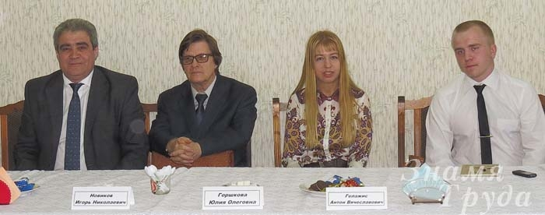

From May 20 to May 22, the first inter-municipal ecological meeting of schoolchildren of grades 8-10 of the Baryatin, Kirov and Kuibyshev districts "Give the planet life" took place in a picturesque place on the territory of the Kuybyshevsky forestry of the Kaluga region.
The initiator and organizer of the ecological gathering was the Working Group on Environmental Education of the Kirovsky district, coordinated by Mikhail Chuprinin, the editor-in-chief of the Kirov regional newspaper «Banner of labor». The ecological meeting was also held with the support of the heads of administrations of the Kirov, Baryatin and Kuibyshev districts.
More than 80 schoolchildren from the Kaluga region, students of the Orthodox Sunday School at the Alexander Nevsky Cathedral in Kirov, ecology students of the Kaluga State University, Tsiolkovsky.
The main goal of the ecoclet is to make sure that children from a young age change their attitude towards nature so that when they grow up they become more responsible for the results of their life activity.
For the children participating in the meeting, the organizers developed an educational program on environmental, patriotic and spiritual upbringing. It included creative competitions, cognitive tours and excursions.
In order to form an ecological outlook, Yulia Gorshkova conducted "eco-lessons" for senior pupils with elements of discussion. During the "eco-lessons", global and regional environmental problems were discussed, the "golden rules" of nature management proposed by the well-known ecologist B. Commoner, the model of sustainable development and the "ecological footprint" of man as an integral indicator of the impact on the environment.
Among the guests of the ecological meeting were Jorg Ratman, the general director of the firm "TOMRA" (Germany), engaged in waste sorting and utilization, and Igor Lykov, doctor of biological sciences, professor, head of the Kaluga State University named after. K.E. Tsiolkovsky, the head of the Committee for Nature Management and Ecology of the Kaluga Chamber of Commerce and Industry.
The general director of the German company Tomra Sorting Jörg Ratman held a lesson for participants of the ecology camp about what solid municipal waste is, how much TKO Russia produces, how much useful it can be extracted from waste and how to make money on them.
Ecology of the invisible world dedicated his speech to Igor Lykov. Sounded from him, the doctor of biological sciences, professors, information about microorganisms, and specifically bacteria, made an unforgettable impression on the listeners. Children have learned that bacteria are the first inhabitants of the planet and the creators of life on Earth, and they are still controlling it.
Deputy Director of Kuibyshev Forestry Artem Berezin opened for the participants of the meeting the beauty and uniqueness of the forest of the central part of Russia. The children remember that the forest is an ecological system. Its living form is trees. They are the most important forest component.
The schoolchildren of the three districts together with the employees of the Kuibyshev Forestry within the framework of the action "All-Russian Forest Planting Day" planted about 80 thousand tree seedlings.
Important among the activities for patriotic education was the visit to the Memorial Complex "Nameless Height" and the Bratsk grave of Soviet soldiers in the village of Vysokoye of the Kuybyshevsky district, in which the participants of the meeting, representatives of the Working Group on Environmental Education and guests took part.
At the solemn closing of the inter-municipal ecological rally, memorable badges and T-shirts were handed to all its participants and guests.

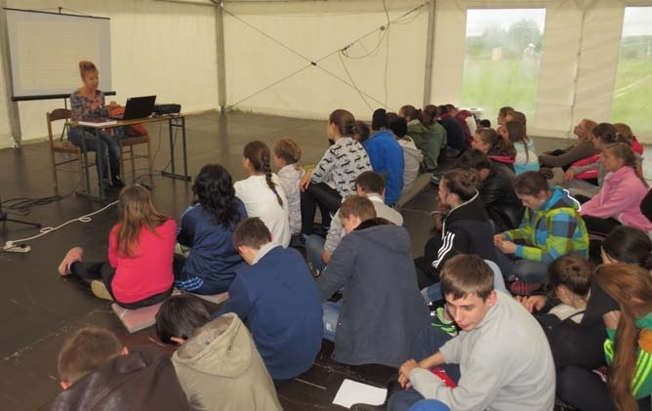
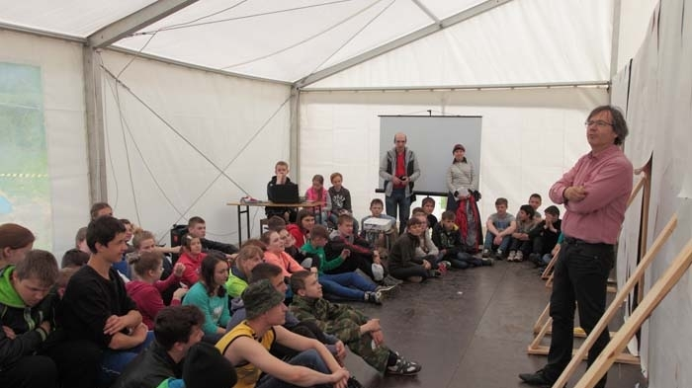
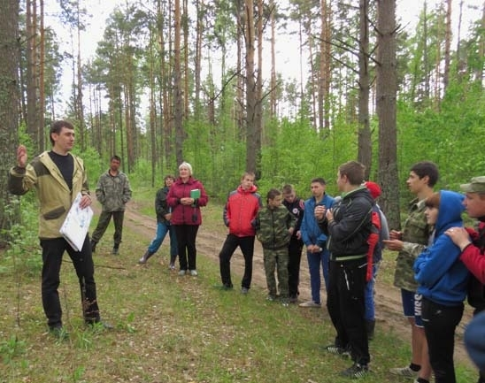
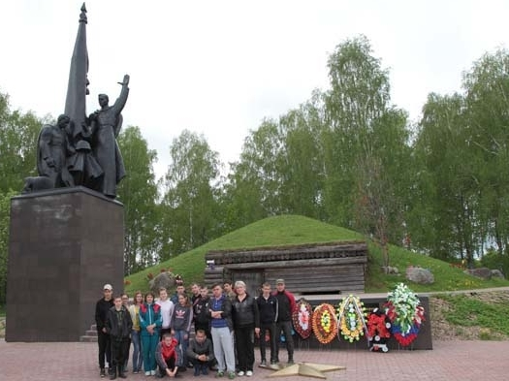
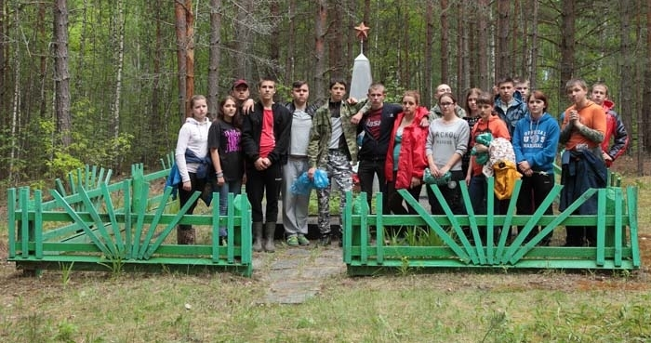
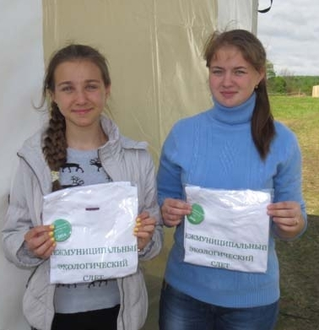
3.3.2 Production Environmental Control

The company's goals are to ensure openness, security, resilience and sustainability of cities and settlements; Ensuring availability and rational use of water resources and sanitation for all; Protection, restoration of terrestrial ecosystems and promotion of their rational use.
To increase the environmental sustainability of the city, it is necessary to improve air quality and reduce waste and increase the area of ​​green areas.
The company's policy in the field of environmental protection is aimed at reducing the negative impact on the nature of waste generated in the process of vital activity of the population.
To achieve the set goals, Remmontazh monitors and analyzes the impact of the TCO landfill on the state of the environment.

Control of atmospheric air pollution

The industrial control of chemical pollution of the atmosphere is divided into two types:
- control directly on emission sources;
- control of the content of harmful substances in the ambient air at the border of the sanitary protection zone.
The main tasks of industrial control of emission sources are to assess the qualitative and quantitative composition of emissions directly from sources of emissions.

The main sources of atmospheric air pollution at the site are the territory of the working maps of the landfill; Vehicles transporting waste; Motor vehicles operating on the territory of the test site.
Liquefied deposits are gas generating objects that pollute the atmospheric and subsoil air with biogas. The composition of the biogas produced at the landfill depends on a number of factors, such as the stage of the decomposition process, the composition of the waste, the storage height, the compaction conditions, etc.
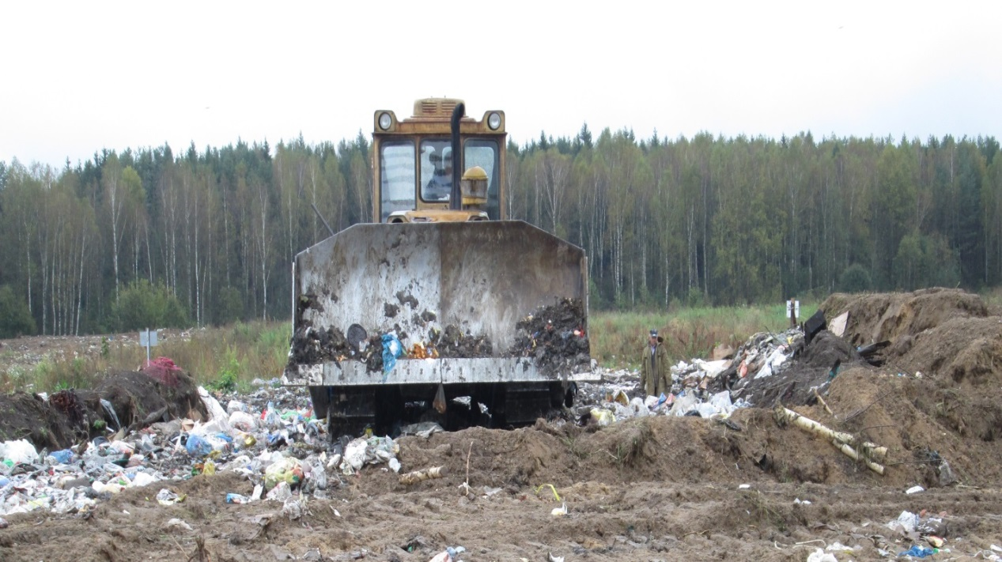
Measurements, processing of observations and estimation of air pollution are carried out in accordance with GOST 17.2.1.01, GOST 17.2.1.03, GOST 17.2.4.02, GOST 17.2.6.02 according to the regulatory and methodological and guidance documents of the Federal Service for Hydrometeorology and Environmental Monitoring and the Federal Service On supervision in the field of consumer rights protection and human well-being (Rospotrebnadzor) and GN 2.1.6 1338-03.
The estimation of atmospheric pollution is carried out separately for each substance and each combination of substances in the summable unidirectional harmful actions.
The degree of air pollution is established by the multiplicity of the excess of the results of measurements at the SPZ of the content of harmful components at the average daily maximum allowable concentration (MPCAS), taking into account the hazard class, the total biological effect of air pollution at a certain frequency of excesses (MPCAS).
With the prevalence of anaerobic processes, the main components of biological gas, which threaten the ecological well-being, are methane (CH4) and carbon dioxide (CO2). As the most important impurities, hydrogen (H2), hydrogen sulphide (H2S), other compounds can be present. In connection with this, when using landfill sites, a number of possible dangerous phenomena should be considered, such as:
- fire and explosion situations;
- deficiency of oxygen;
- toxicological adverse conditions;
- unpleasant odors;
- depression of vegetation.

The laboratory quality control of atmospheric air is carried out under contracts with FGBU "Center for Laboratory Analysis and Technical Measurements in the Central Federal District", FGUZ "Center for Hygiene and Epidemiology in the Kaluga Region in the Kirov District".
As a result of studies of atmospheric air, no excess was detected. Consequently, the TKO landfill does not adversely affect the atmospheric air.

Control of pollution of water bodies

In the territory of the TKO landfill near the village of Zimnitsa, there is no organized discharge of sewage into surface water bodies. Pollution of water bodies can occur as a result of flat flushing of pollutants along with storm and thawed waters. Thus, in the framework of industrial and environmental control, the quality of surface water in the river is controlled. Bolva (target number 1) and the river. To squeeze (target No. 2) relative to the background sections on the rivers where there is no influence on them of the range - the target number 3 below the body of the test site, the target number 4 is higher than the body of the test site.
Monitoring of natural waters is carried out twice a year during peak periods of the hydrological regime: spring high water, autumn low water, or floods.
Sampling of water, the necessary conservation, storage and transportation is carried out in accordance with the requirements of GOST 31861-2012 ("Water: General Requirements for Sampling").

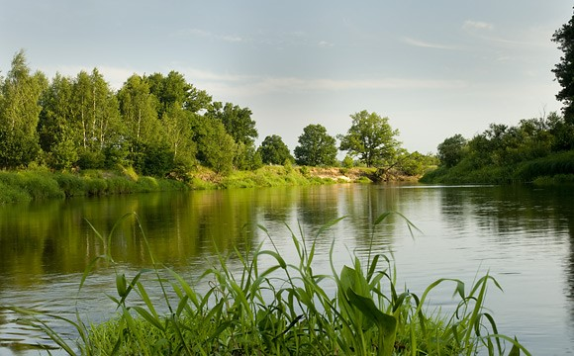

ООО «Remmontazh» does not conduct an organized discharge of sewage into underground aquifers when carrying out activities on a leased TKO landfill.
The source of pollution of underground aquifers may be the filtration water that has leaked through the body of the landfill and is contaminated with hazardous substances. Thus, industrial and environmental monitoring of groundwater pollution is carried out by comparing the quality of water in the background and control wells. Organization of a network of background and observation wells in accordance with regulatory documents is provided for in the sections. The location of the track is selected taking into account the main direction of the groundwater flow.
The design of the wells ensures protection of groundwater from accidental contamination in them and is convenient for sampling water.
Hydrochemical observations are carried out twice a year (spring, autumn) to determine the seasonal changes in the quality of groundwater, filtration water and the thickness of the contaminated soil layer in the study area.

Laboratory quality control of surface and groundwater is carried out under contracts with FGBU "Center for Laboratory Analysis and Technical Measurements in the Central Federal District", FGUZ "Center for Hygiene and Epidemiology in the Kaluga Region in the Kirov District".
The TCO landfill does not have a negative impact on water bodies, because as a result of the conducted studies, the water samples comply with the requirements of the National Sanitary and Epidemiological Service, therefore, we operate within the framework of environmental legislation.

Control of soil contamination

Soil testing in environmental surveys is carried out for ecotoxicological assessment of the adjacent area to the landfill as a component of the environment, capable of accumulating significant amounts of pollutants and having a direct impact on the health of the population.
Sampling is performed in accordance with GOST 17.4.3.01, GOST 17.4.4.02-84 and GOST 28168. It is recommended to test the surface layer from the surface layer using the "envelope" method (mixed sample on an area of ​​20-25 m2) to a depth of 0.0-0.9 M.
The assessment of the level of chemical contamination by heavy metals and arsenic of soils, man-made soils and bottom sediments is estimated from the total value of chemical contamination (Zc), which is an indicator of adverse effects on public health.
In the absence of actual data on the regional-background content of controlled chemical elements in soil, the use of reference materials is allowed.
Assessment of the level of chemical contamination of soils and soils is determined in accordance with SanPiN 2.1.7.1287.

Laboratory control of the soil is carried out under contracts with the Federal State Institution "Center for Laboratory Analysis and Technical Measurements in the Central Federal District", FGUZ "Center for Hygiene and Epidemiology in the Kaluga Region in the Kirov District".
As a result of soil studies, the negative impact of the TKO landfill on soil quality was not revealed.

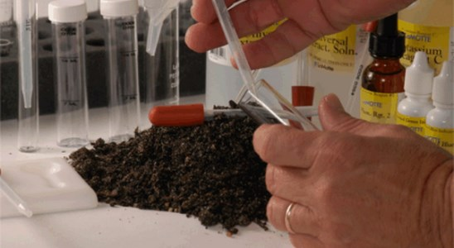

Control of noise pollution

During the operation of the landfill, garbage trucks and tractors operate - all this creates a certain noise load on people who are at the range and live nearby. In this connection, it is planned to measure equivalent sound levels and sound power levels at the polygon and SPZ border.
Monitoring of noise pollution is carried out in the unloading area of ​​garbage trucks and waste disposal in accordance with GOST 27409-97, UNECE Regulations No. 48-03, ext. 1-3, SN 2.2.4 / 2.1.8.562-96, GOST R ISO 9612-2013, Sanitary rules for the hygiene of drivers of cars No. 4616-88 and on the border of the SPZ.
Laboratory monitoring of noise pollution is carried out under contracts with the FGUZ "Center for Hygiene and Epidemiology in the Kaluga Region in the Kirov District".
At the TKO site, measurements are made of equivalent sound levels and sound power levels at the polygon and SPZ boundary. As a result of the measurements, the sound levels meet the requirements.

Control of radiation contamination

The assessment of the radiation situation is carried out as part of environmental monitoring, since the storage of waste at landfills does not exclude situations related to the accidental ingress or deliberate disposal of radioactive substances in man-made soil that present a radioecological hazard.
Also, in order to ensure the radiation safety of personnel carrying out waste disposal work, it is necessary to conduct a radiation survey of man-made soils and the surrounding area in the course of their implementation.
Radiation survey of landfill soils is carried out in order to fulfill the requirements of SP 2.6.1.758 pp. 5.1.-5.3 (NRB-2010) in terms of limiting the exposure of people to technogenic and natural sources of ionizing radiation.
Laboratory radiation monitoring is carried out under contracts with the FGUZ "Center for Hygiene and Epidemiology in the Kaluga Region in the Lyudinovsky District".
As a result of the research, the gamma radiation DER values ​​at the site are within the permissible level. No surface radiation anomalies were found on the territory. The investigated soil samples meet the requirements.

3.4 Anti-Corruption

Corruption is an important systemic problem, characteristic not only for Russia, but for most countries of the world. In this regard, one of the primary tasks, in recent years, put at the state level in Russia, was the fight against corruption.
The company's goal is to promote the adoption and strengthening of measures aimed at more effective and effective prevention of and fight against corruption.
Anticorruption policy of OOO «Remmontazh» is a set of interrelated principles, procedures and specific measures aimed at preventing and suppressing corruption offenses in the company's activities.
The main circle of persons affected by the policy are the employees of the company who are with her in labor relations, regardless of the position held and the functions performed, as well as other persons, physical and (or) legal, with whom the company enters into other contractual relations.
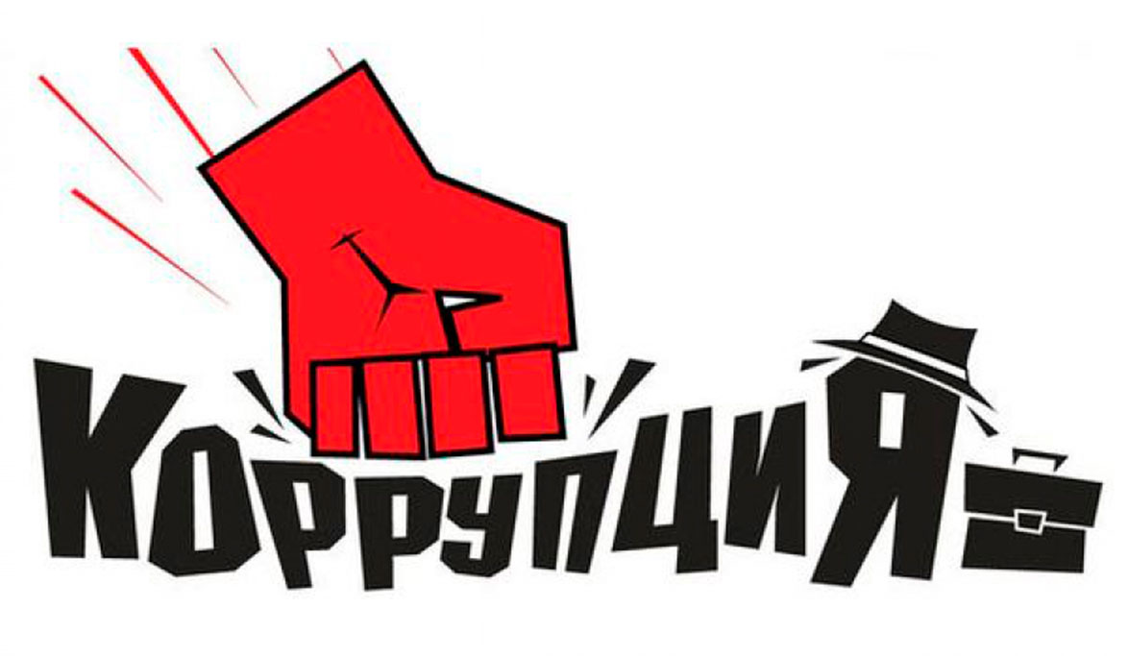

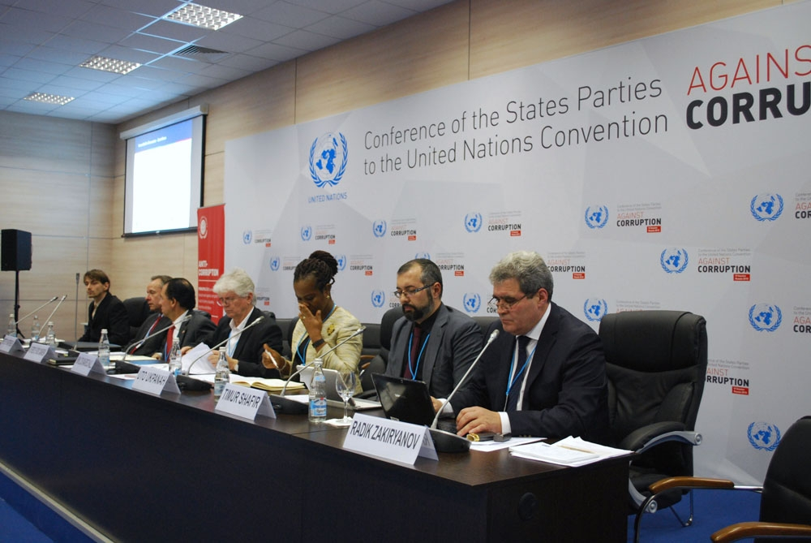

The system of anti-corruption measures of OOO Remmontazh is based on the following key principles:
1. The principle of compliance of the company's policy with the current legislation and generally accepted norms.
Correspondence of anti-corruption measures implemented by the Constitution of the Russian Federation concluded by the Russian Federation with international treaties, legislation of the Russian Federation and other normative legal acts applicable to the company.
2. The principle of a personal example of leadership.
The key role of the company's management in the formation of a culture of intolerance towards corruption and in the creation of an intra-organizational system for preventing and combating corruption.

3. The principle of employee involvement.
Awareness of the company's employees on the provisions of the anti-corruption legislation and their active participation in the formation and implementation of anti-corruption standards and procedures.
4. Principle of effectiveness of anti-corruption procedures.
The use of such anti-corruption measures at the enterprise that are of low cost, ensure the simplicity of implementation and bring a significant result.
5. The principle of responsibility and the inevitability of punishment.
The irrevocability of punishment for the employees of the organization regardless of the position held, work experience and other conditions in case of committing them corruption offenses in connection with the performance of labor duties, as well as the personal responsibility of the organization's management for the implementation of internal anti-corruption policy.
Thus, the proper organization and implementation of anti-corruption measures become important tasks and a key to the successful operation of the company.

4 Conclusion

ООО «Remmontazh» (Kirov, Kaluga Region), a member of the Kaluga Chamber of Commerce and Industry, is a young, dynamically developing company that provides services in the sphere of handling waste products of the 4th class of danger in the Kirov, Baryatinsky and Lyudinovsky districts of the Kaluga region.
ООО «Remmontazh» constantly focuses on increasing the efficiency of production, as the basis for further development of the company. Uses modern information technologies in its activities in logistics, in accounting for education and waste movement, in monitoring the quality of services provided in the field of communication with waste. This has a very positive effect on the growth of labor productivity.
Observance of workers' rights is an integral part of the social policy of Remmontazh. The company strictly observes the norms of the Labor Code of the Russian Federation.
The leadership of Remmontazh pays much attention to raising the level of qualification of its employees, taking advantage of the opportunities of the Kaluga Chamber of Commerce and Industry, which organizes training seminars for specialists. Employees of the company constantly participate in seminars and specialized exhibitions to enhance their own professionalism.
Implementing the "Zero waste" program, we proved that separate waste collection and environmental education is a single process. The goal of environmental education is to educate the model of environmentally responsible behavior in its life activity in the younger generation and to instill in the population a model of ecologically responsible behavior, and separate collection of waste is the practical implementation of this model.

As a result of studies of atmospheric air, no excess was detected. Consequently, the TKO landfill does not adversely affect the atmospheric air.
The TKO landfill does not have a negative impact on water bodies, because as a result of the conducted studies, the water samples comply with the requirements of the National Sanitary and Epidemiological Service, therefore, we operate within the framework of environmental legislation.
As a result of soil studies, the negative impact of the TKO landfill on soil quality was not revealed.
At the TKO site, measurements are made of equivalent sound levels and sound power levels at the polygon and SPZ boundary. As a result of the measurements, the sound levels meet the requirements.
Since the storage of waste at landfills does not exclude situations related to the accidental ingress of radioactive substances in man-made soil, representing radioecological hazards, an assessment of the radiation situation was carried out. As a result of the research, the gamma radiation DER values ​​at the site are within the permissible level. No surface radiation anomalies were found on the territory. The investigated soil samples meet the requirements.
The improvement of anti-corruption activities must be linked to the complex implementation of legal, political, organizational, technical and financial measures that ensure the development of the necessary mechanisms, the implementation of which will create serious prerequisites for a radical change in the situation in the sphere of combating large-scale manifestations of corruption.

